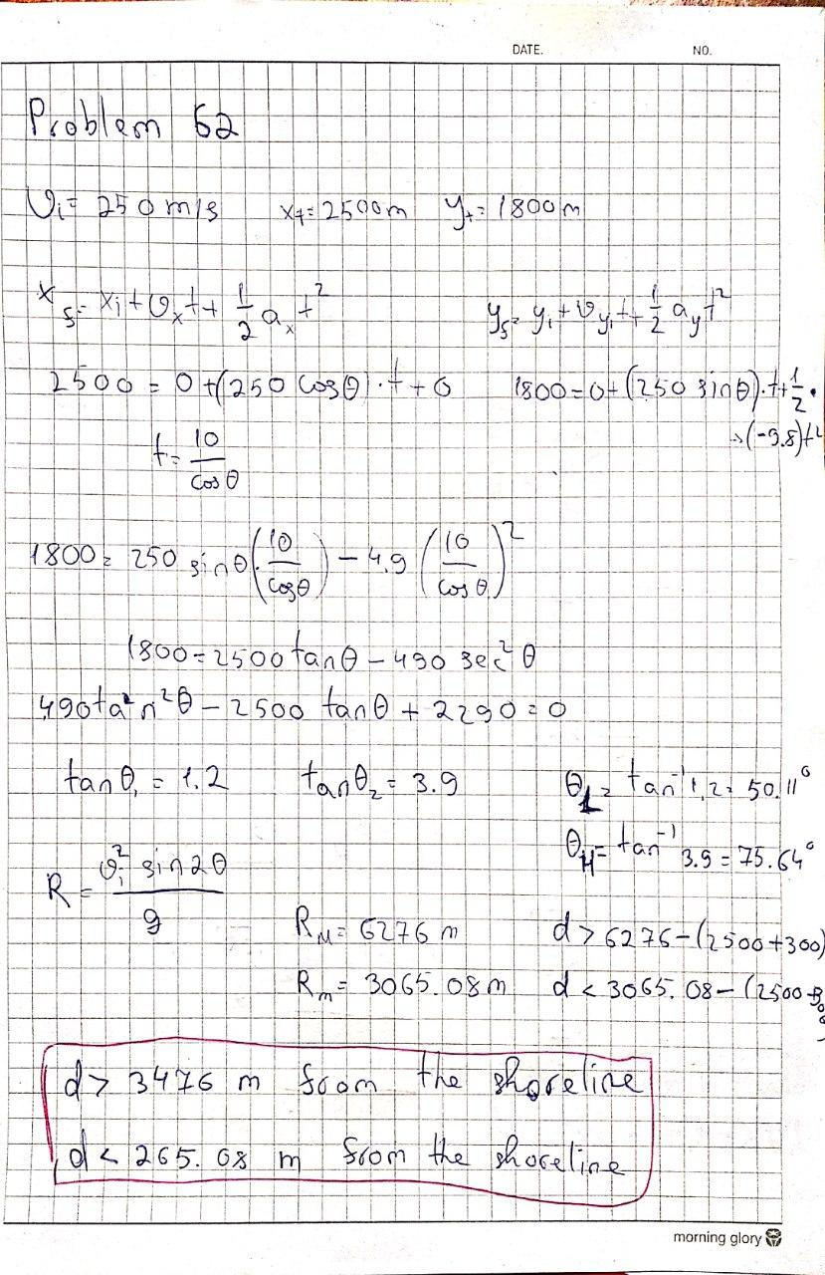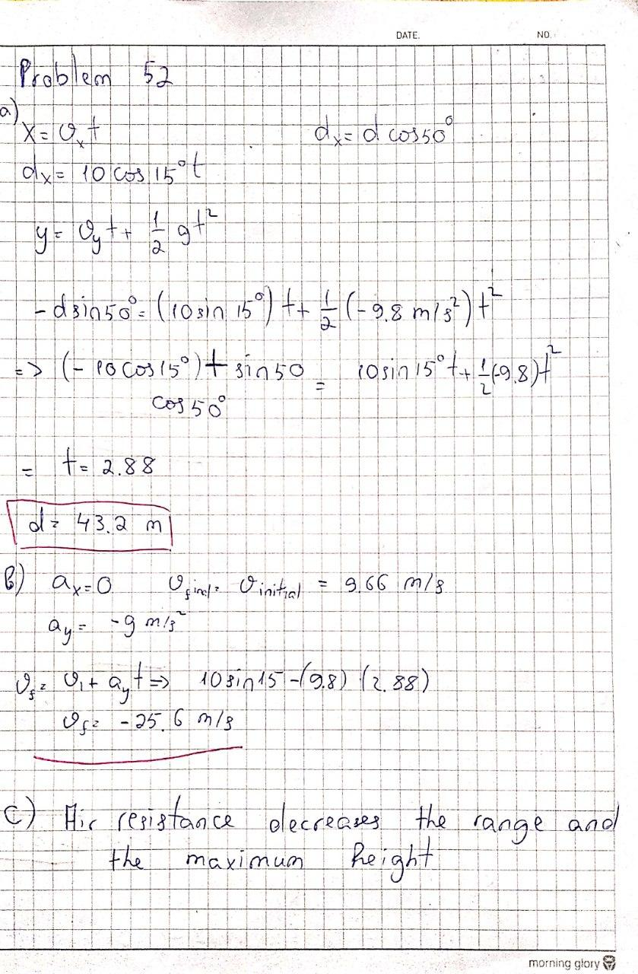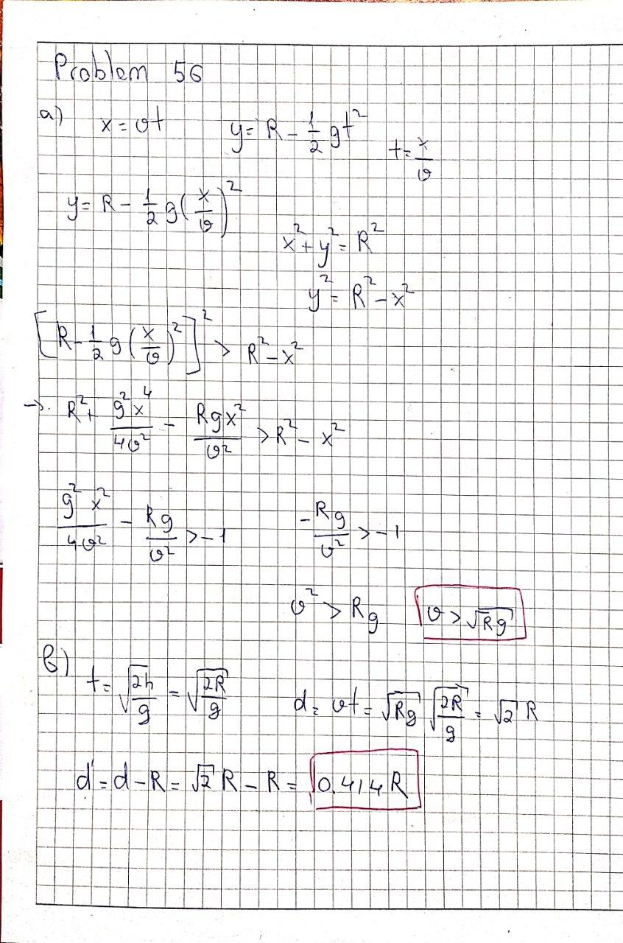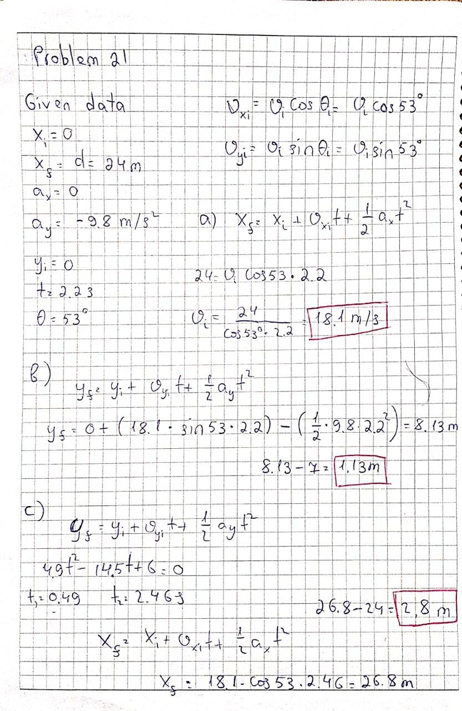

Objective question 3

Acceleration of the car must have an internal component and an external component: answer (e). Another argument is that you draw two units west of the final velocity vector. Attach a single vector unit to the south of it. It implies that the initial velocity is subtracted from the final velocity on the way to the acceleration. The resulting direction is that of the vector (e).

Objective question 4

An angle of 45 ° means that horizontal and vertical velocity components are equal at point A. The part of horizontal velocity is identical at A, B, and C. The component of vertical velocity is zero at B, and negative at C. The answer put together is a = b = c > d = 0 > e.

The x acceleration factor is zero all over and the y factor is −9.8 m / s2 everywhere. We then get a = c = 0 > b = d = e.

Thank you!

Student ID : 201923250

Name : Ilkhomjon Kobilov